C.A.T.L NEWS
In recent months, a new force seems to be arising in German politics. Adolf Hitler and the NAZI`s had hit the headlines With their meetings, banners and the radical ideas. What makes this man successful?
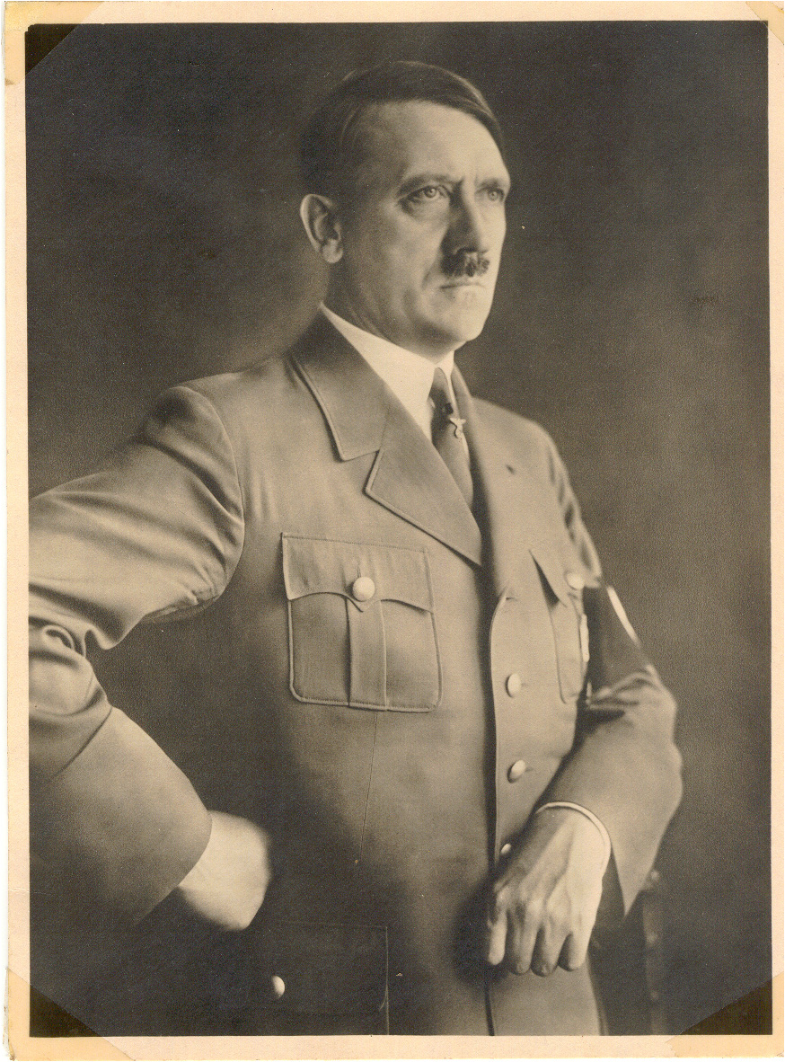
He was born in 1889. He had a bad relationship with his dad, but was a fond with his mother. When he was sixteen he left school and went to Vienna to be a painter, unfortunately he failed. Adolf Hitler later entered the army and with the hate against Jews he was gathering this years he joined a group called German worker`s party or NAZI`s led by Anton Drexer

